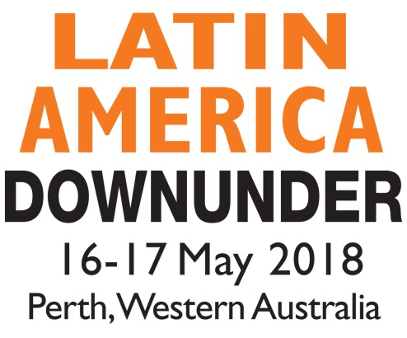

Yes! I would like to purchase the CD Rom of presentations from
Latin AMerica down under, 16-17 MAY 2018

CD for Conference Delegate - $50 (inc GST)
CD for Non-Conference Delegate - $80 (inc GST)

NAME:

COMPANY:

ADDRESS:

PHONE:

FAX:

EMAIL:

NUMBER OF COPIES:

Payment method: Cheque Bankcard MasterCard Visa

Amex* Diners*

*Please note that a surcharge of 3.8% (inc. GST) applies to payments made on Amex and Diners

Card Number: __________________________________________________________________
Exact Name of Card: _____________________________________________________________
Amount: ____________________________ Expiry Date: _______________________________
Signature: _____________________________________________________________________
Please return to: Paydirt Media Pty Ltd, PO Box 1589, WEST PERTH WA 6872 AUSTRALIA
Fax: +61 8 9321 0426 Email: melita@paydirt.com.au

